[CEN 323 ] Computer Organization & Assembly Language
Lab 4 Journal

Name :Bilal Aamir
Enrollment Number: 01-135232-016

Lab Deliverables (submission guideline)

Create a folder named after your enrollment number and add the following files:
  - Create a folder named YourRollNumber_Lab4 containing:
- .asm files of the three practice tasks.
- Add full screen screenshots of the code and output in this word file.
  - Zip the Folder and upload to LMS.

Lab Task

Task 1:
Code (TEXT):
.data

dividend db 4
divisor db -2
dividend2 db -4
divisor2 db -2

.code
main:

mov ax,@data
mov ds,ax
mov ax,0
mov al,dividend2
CBW
IDIV divisor2
mov bl,al ; Just to see the AX register for -4 / -2
mov al,dividend
CBW
IDIV divisor
mov bl,al ; Just to see the AX register for 4 / -2
end main

Screenshot (CODE):
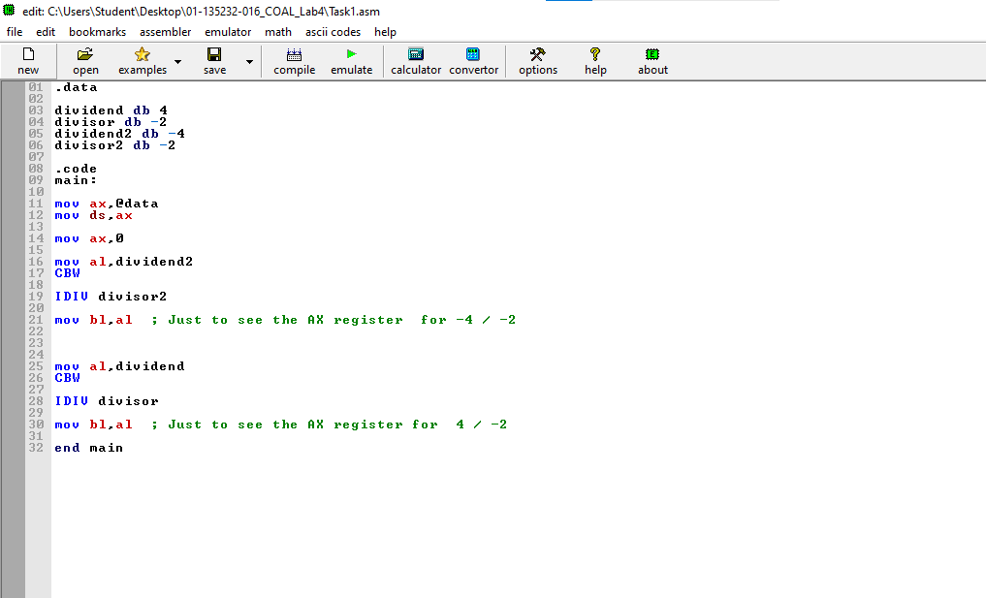

Screenshot (OUTPUT):
Negative / Negative
-4 / -2
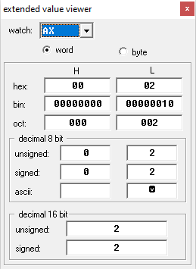

Positive/negative
4 / -2
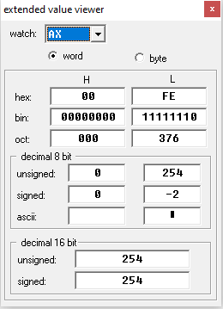

Task 2:
Code (TEXT):
.data

var1 db -2
var2 db -2
divisor db -2

msg1 db "The result of -2 x -2: $"
msg2 db "The result of 4/-2: $"

.code
main:

mov ax,@data
mov ds,ax

LEA dx,msg1
mov ah,09h
int 21h
mov ax,0
mov al,var1
IMUL var2
mov bl,al ; To see the answer of - 2 x -2
IDIV divisor
mov bl,al ; To see the answer of 4 / -2
end main
Screenshot (CODE):
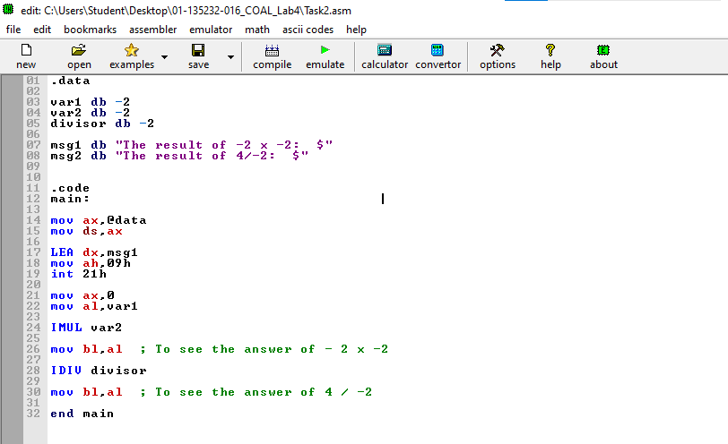
Screenshot (OUTPUT):
Negative x Negative
-2 x -2
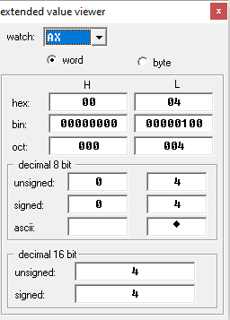
Positive / Negative
4 / -2
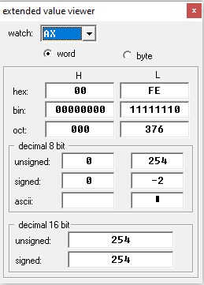

Task 3:
Code (TEXT):
.data

num1 db ?
num2 db ?
num3 db ?
hundred db 100
tens db 10
res db ?
temp db ?
space db 10,13,"$"

msg1 db "Enter the value of first number: $"
msg2 db "Enter the value of second number: $"
msg3 db "Enter the value of third number: $"
msg4 db "The number is : $"
.code
main:

mov ax,@data
mov ds,ax
mov ah,09h
LEA dx,msg1
int 21h
LEA dx,space
int 21h
xor ax,ax
mov ah,01h
int 21h
mov num1,al
sub num1,48
mov ah,09h
LEA dx,space
int 21h
;First number input stored
mov ah,09h
LEA dx,msg2
int 21h
LEA dx,space
int 21h
xor ax,ax
mov ah,01h
int 21h
mov num2,al
sub num2,48
mov ah,09h
LEA dx,space
int 21h
;Second number input stored
mov ah,09h
LEA dx,msg3
int 21h
LEA dx,space
int 21h
xor ax,ax
mov ah,01h
int 21h
mov num3,al
sub num3,48
mov ah,09h
LEA dx,space
int 21h
;Third number input stored
xor ax,ax
mov al,num1
mul hundred
mov res,al
;Result is 100
xor ax,ax
mov al,num2
mul tens
add res,al
;20 added in 100
mov al,num3
add res,al
;3 added in 100
;Now break the number into parts to print it
mov ax,ax
mov al,res
div hundred
mov num1,al
mov temp,ah
xor ax,ax
mov al,temp
div tens
mov num2,al
mov num3,ah
add num1,48
add num2,48
add num3,48
mov ah,09h
LEA dx,msg4
int 21h
mov ah,02h
mov dl,num1
int 21h
mov dl,num2
int 21h
mov dl,num3
int 21h
mov ah,4Ch
int 21h
end main

Screenshot (CODE):

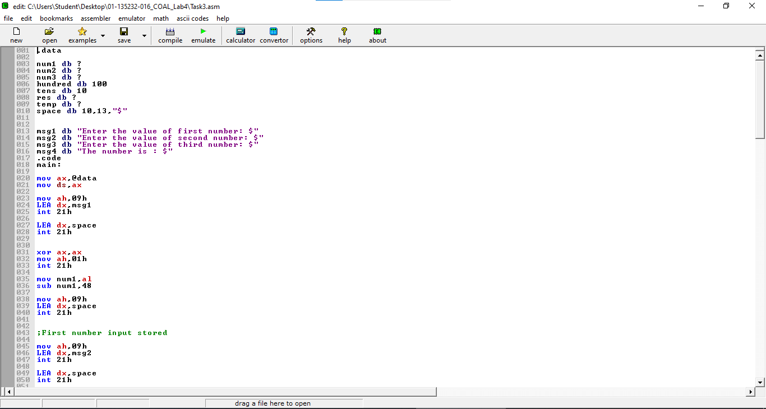
Screenshot (OUTPUT):
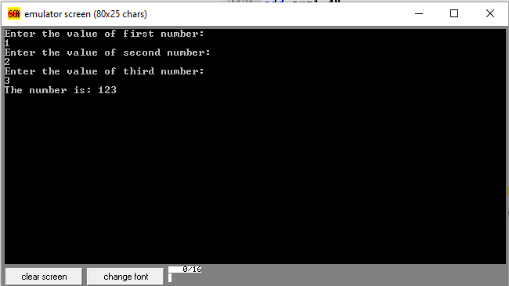

The number constructed using single digits in result :
